**AI Assignment 6**

Sharvari Deshmukh

TY CSA 73

**Problem Statement**- Implementation of expert system using PROLOG.

**Expert System-**

* An expert system emulates the decision-making ability of a human *expert*.
* It is built using a knowledge base of expert rules and a reasoning engine.

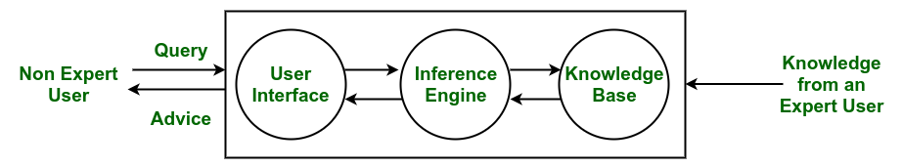

**Knowledge Base:** Contains the domain-specific knowledge and rules used by the system.

**Inference Engine:** Processes information from the knowledge base to make decisions or draw conclusions.

**User Interface:** Allows users to interact with the system and receive information or recommendations.

Below is an expert system that classifies whether the **person is fit or unfit** based on the following **parameters**-

1. **Exercise Frequency**
2. **Junk Food Frequency**
3. **Sleep Time**
4. **Screen Time**

**Rules-**

Fit Person-

1. Exercise Frequency >= twice a week
2. Junk Food Frequency = low
3. Sleep Time >=7hrs
4. Screen Time= low/moderate

Unfit Person-

1. Exercise Frequency < twice a week
2. Junk Food Frequency = moderate/high
3. Sleep Time < 7hrs
4. Screen Time= high

A person can be neither fit nor unfit if they satisfy neither of the above conditions

